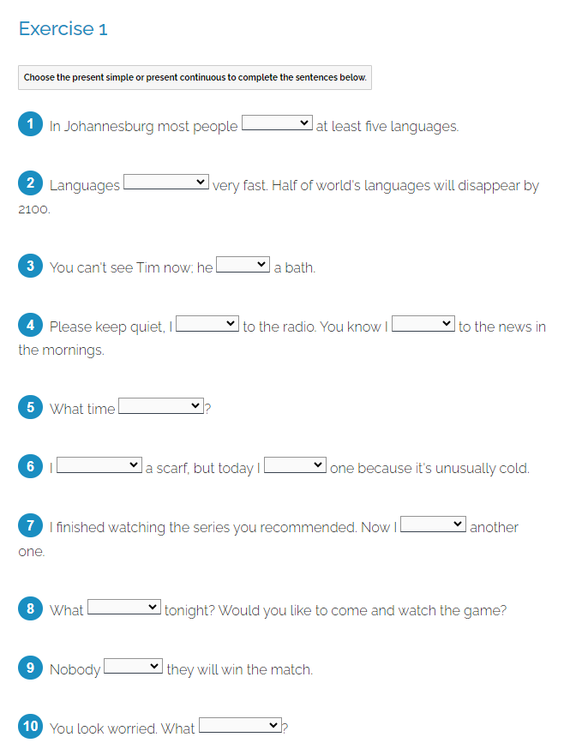

https://test-english.com/grammar-points/b1/present-simple-present-continuous/

